Aim – Create MongoDB database with the following Data types – String, Integer, Boolean, double, min/max keys, arrays, timestamp, object, Null, symbol, date, object ID, Binary data, Code, Regular Expression.

Learning outcome: Able to configure embedded databases with different web pages using MongoDB.

Duration: 3 hours

List of Hardware/Software requirements:

1. Laptop/Computer with Linux OS - Ubuntu 18.04 LTS
2. MongoDB 6.0.5 Community Edition

**Follow the below step’s**

* Step -1 Open the CMD/windows PowerShell.
* Step -2 Know just type **mongosh** and enter. (Here mongodsh is use to show connection between the mongoDBCompass and see below image).

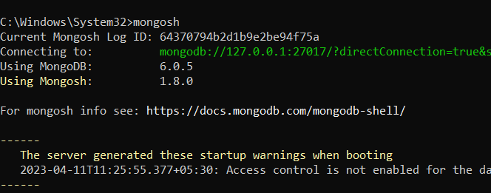

* Step -3 After the 2nd step just type the **show dbs** and enter. Here you can see all databases and they have a default database which name is test (Here show dbs is use to show the all-available databases and see below image).

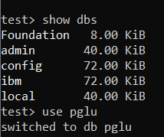

* Step -4 Type **use pglu** and enter (This CMD use for select database but upper image there don’t have any pglu database. That’s mean here we can use a new database which name is pglu but they don’t have any Documents (MySQL name -Rows) and Fields (MySQL name -Columns) let’s see the upper image and 5th step also).

**This cmd use for insert only one Value**

* Step -5 Type **db.Emp.insertOne({name:”Payal”,salary:19000})** and enter. (This cmd use to insert only one value into the database).

**Input:**

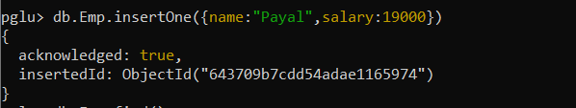

**Output:**

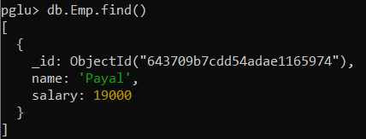

**This cmd use for insert muntip Value**

* Step -7 Type **db.Emp.insertMany([{name:"Payal",salary:19000},{name:"Priyanka",salary:25000},{}])** and enter (This cmd use to insert many values into the database see the below image).
* **db.Emp.find().pretty()** this cmd is use for show fields.

**Input:**

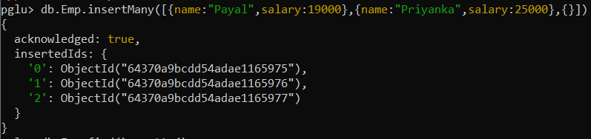

**Output:**

